**CAD_Phase 2**

**Project name :**

**3118-Data Warehousing with IBM Cloud Db2 Warehouse**

Develop a cloud-based predictive analytics and sales optimization platform that leverages IBM Db2 Warehouse on Cloud to provide actionable insights to businesses. This platform will help businesses make data-driven decisions to improve their sales strategies, customer engagement, and ultimately increase revenue.

**Data Integration:**

Integrate IBM Db2 Warehouse with various data sources, such as CRM systems, e-commerce platforms, social media, and more, to create a centralized data repository.

**Machine Learning Models:**

Utilize machine learning algorithms to analyze historical sales data, customer behavior, and market trends. Develop predictive models to forecast future sales and identify potential upsell and cross-sell opportunities.

**Personalized Recommendations:**

Provide personalized product recommendations to customers based on their purchase history and preferences. This can increase average order value and customer satisfaction.

**Inventory Optimization:**

Use real-time inventory data from the cloud database to optimize stock levels, ensuring that products are in stock when customers want them. Avoid overstocking or understocking issues.

**Customer Segmentation:**

Segment customers based on various criteria, including demographics, purchase history, and engagement patterns. Tailor marketing campaigns and promotions to specific customer segments for better targeting.

**Dynamic Pricing:**

Implement dynamic pricing strategies by analyzing competitor pricing, demand fluctuations, and historical sales data. Adjust prices in real-time to maximize revenue.

**Sales Performance Dashboard:**

Provide a user-friendly dashboard for businesses to track their sales performance in real-time. Include key performance indicators (KPIs), revenue trends, and actionable insights.

**A/B Testing:**

Conduct A/B tests for marketing campaigns and product offerings. Analyze the results to fine-tune strategies and maximize conversion rates.

**Predictive Maintenance:**

For businesses with physical products, use predictive maintenance models to anticipate equipment failures and minimize downtime, ensuring continuous operations**.**

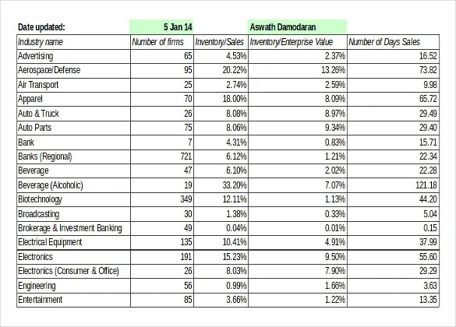

**1. Project Planning:**

* Define clear objectives: Determine what specific insights you aim to gain from the sales and revenue data.
* Identify data sources: List all the sources of sales data, such as POS systems, e-commerce platforms, CRM systems, and marketing databases.
* Set project timelines and budget: Plan the project schedule and allocate resources accordingly.

**2. Objectives and Requirements:**

Before diving into the technical aspects, it's crucial to understand the specific objectives and requirements of your Sales and Revenue Analysis project. This includes:

* Identifying the key performance indicators (KPIs) you want to track (e.g., revenue, profit margin, customer acquisition cost).
* Determining the level of granularity required for your data (daily, weekly, monthly).
* Understanding the sources of data (e.g., point-of-sale systems, online sales platforms, CRM systems).
* Defining the scope of customer behavior analysis (e.g., customer segmentation, lifetime value analysis).

**3. Data Collection and Integration:**

Once you've defined your objectives and requirements, you can start collecting and integrating data from various sources:

* Extract data: Extract sales and revenue data from your different sources. This may involve using ETL (Extract, Transform, Load) tools or APIs provided by these systems.
* Data cleansing: Cleanse and preprocess the data to ensure consistency and quality. This may involve handling missing values, removing duplicates, and standardizing data formats.
* Data integration: Integrate the cleaned data into a central repository. In the case of IBM Db2 Warehouse, you can use its capabilities for data integration and transformation**.**

**4. Data Modeling and Schema Design:**

Design the data model for your data warehouse. This involves creating tables and defining the relationships between them. For a Sales and Revenue Analysis project, you might have tables for:

* Sales transactions
* Products
* Customers
* Time (date dimension)
* Revenue and profit calculations

**5. Data Transformation and ETL:**

Develop ETL (Extract, Transform, Load) processes to transform raw data into a format suitable for analysis:

* Calculate derived metrics: Calculate additional metrics like gross profit, profit margin, and average order value.
* Aggregate data: Summarize data at the desired level of granularity (e.g., monthly revenue, weekly sales trends).
* Load data: Load the transformed data into your Db2 Warehouse tables.

**6. Real-time Data Integration (Optional):**

If real-time analysis is a requirement, consider implementing real-time data integration solutions to continuously update your data warehouse as new sales data arrives.

**7. Analytics and Reporting:**

With your data warehouse populated, you can now perform real-time analysis and reporting:

* Use SQL queries to generate reports and dashboards that provide insights into sales trends, revenue performance, and customer behavior.
* Implement data visualization tools (e.g., Tableau, Power BI) to create interactive dashboards for end-users.
* Implement predictive analytics models to forecast future sales and revenue trends.

**8. Data Security and Compliance:**

Ensure that your data warehouse complies with data security and privacy regulations. Implement access controls, encryption, and auditing as needed to protect sensitive customer and financial data**.**

**9. Scalability and Performance Optimization:**

Monitor the performance of your data warehouse and optimize it as necessary. Db2 Warehouse on IBM Cloud can scale resources dynamically to handle growing data volumes and user demands.

**10. User Training and Adoption:**

Train end-users and stakeholders on how to use the data warehouse and the insights it provides. Encourage adoption by demonstrating the value of data-driven decision-making.

**11. Ongoing Maintenance and Enhancement:**

Regularly maintain and update your data warehouse to accommodate changing business requirements and evolving data sources. Collect feedback from users to identify areas for improvement.

Remember that building and maintaining a data warehouse for Sales and Revenue Analysis is an iterative process. Continuous improvement and adaptation to changing business needs are essential for its long-term success.

**Benefits:**

**Increased Sales:**

By leveraging predictive analytics, businesses can make informed decisions that lead to increased sales and revenue.

**Cost Savings:**

Optimizing inventory, pricing, and marketing efforts can lead to cost savings and improved profitability.

**Customer Retention:**

Personalized recommendations and targeted marketing can enhance customer loyalty and reduce churn**.**

**Competitive Advantage:**

Businesses that use data-driven decision-making have a competitive edge in the market.

**Monetization:**

**Subscription-based model:**

Charge businesses a monthly or annual fee based on the volume of data and features they use.

**Transaction fees:**

Take a percentage of the increased revenue generated through the platform.

**Customization fees:**

Charge for customizing the platform to meet specific business needs.

**Consulting and support services:**

Offer consulting and support services to help businesses make the most of the platform.

By creating a predictive analytics and sales optimization platform powered by IBM Db2 Warehouse on Cloud, you can provide businesses with valuable insights and tools to improve their sales strategies, ultimately leading to increased revenue and long-term customer relationships.